PB.5531.102.2022 03.03.2022

Ostrzeżenie 2 stopnia dla: miasta Krakowa, miasta Nowego Sącza, powiatu chrzanowskiego, powiatu krakowskiego, powiatu nowosądeckiego, powiatu nowotarskiego, powiatu olkuskiego, powiatu oświęcimskiego, powiatu suskiego, powiatu wielickiego, powiatu wadowickiego

POZIOM 2
Powiadomienie o przekroczeniu poziomu informowania
i o ryzyku wystąpienia przekroczenia poziomu informowania
dla pyłu zawieszonego PM10 w powietrzu

INFORMACJE O PRZEKROCZENIU POZIOMU INFORMOWANIA
Zagrożenie | Wystąpienie przekroczenia poziomu informowania (100 µg/m3) dla pyłu zawieszonego PM10 w powietrzu.
Data wystąpienia | 02.03.2022 r. (godz.00.00-24.00)
Stężenia dobowe pyłu PM10 na stacjach | Przekroczenie poziomu informowania wystąpiło na stacji:  Sucha Beskidzka, ul. Nieszczyńskiej – 118,8 µg/m3
Obszar przekroczenia | Obszar przekroczeń poziomu informowania obejmował: powiat suski.
Ludność narażona | Liczba mieszkańców obszaru, na którym wystąpiło przekroczenie poziomu informowania: 83 800.
Przyczyny | Warunki meteorologiczne utrudniające rozprzestrzenianie się zanieczyszczeń w sytuacji wzmożonej emisji z sektora bytowo-komunalnego.

INFORMACJE O RYZYKU PRZEKROCZENIA POZIOMU INFORMOWANIA
Zagrożenie | Ryzyko wystąpienia przekroczenia poziomu informowania (100 µg/m3) dla pyłu zawieszonego PM10 w powietrzu.
Data wystąpienia | 03.03.2022 r. godz. 9.30
Przewidywany czas trwania ryzyka | Od godz. 9.30 dnia 03.03.2022 r. do godz. 24.00 dnia 03.03.2022 r.
Przyczyny | Warunki meteorologiczne utrudniające rozprzestrzenianie się zanieczyszczeń w sytuacji wzmożonej emisji z sektora bytowo-komunalnego
Prognozowana jakość powietrza
Prognoza na dzień 03.03.2022 r. dla stężeń średniodobowych pyłu PM10, przygotowana na podstawie wyników pomiarów Państwowego Monitoringu Jakości Powietrza.
Dzień 03.03.2022 r.
Obszar ryzyka wystąpienia przekroczenia poziomu informowania dla pyłu PM10
Prognozowane na dzień 03.03.2022 r. przekroczenie poziomu informowania dla pyłu PM10 obejmuje powiaty: chrzanowski, krakowski, nowosądecki, nowotarski, olkuski, oświęcimski, suski, wadowicki, wielicki, oraz miasta na prawach powiatu: Kraków i Nowy Sącz.
Ludność narażona na ryzyko wystąpienia przekroczenia poziomu informowania dla pyłu PM10
Ludność zamieszkująca obszar, na którym w dniu 03.03.2022 r. istnieje ryzyko przekroczenia poziomu informowania dla pyłu PM10: 2 314 577.

INFORMACJE O ZAGROŻENIU
Wrażliwe grupy ludności | · osoby cierpiące z powodu przewlekłych chorób serca (zwłaszcza niewydolność serca, choroba wieńcowa),  · osoby cierpiące z powodu przewlekłych chorób układu oddechowego (np. astma, przewlekła obturacyjna choroba płuc),  · osoby starsze, kobiety w ciąży oraz małe dzieci,  · osoby z rozpoznaną chorobą nowotworową oraz ozdrowieńcy.
Możliwe negatywne skutki dla zdrowia | Osoby cierpiące z powodu chorób serca mogą odczuwać pogorszenie samopoczucia np. uczucie bólu w klatce piersiowej, brak tchu, znużenie.  Osoby cierpiące z powodu przewlekłych chorób układu oddechowego mogą odczuwać przejściowe nasilenie dolegliwości, w tym kaszel, dyskomfort w klatce piersiowej, nasilenie się objawów ataków astmy.  Podobne objawy mogą wystąpić również u osób zdrowych. W okresach wysokich stężeń pyłu zawieszonego w powietrzu zwiększa się ryzyko infekcji dróg oddechowych.
Zalecane środki ostrożności | Ogół ludności:  - rozważ ograniczenie intensywnego wysiłku fizycznego na zewnątrz jeśli odczuwasz pieczenie w oczach, kaszel lub ból gardła,  - ogranicz wietrzenie pomieszczeń,  - unikaj działań zwiększających zanieczyszczenie powietrza, np. palenia w kominku.  Wrażliwe grupy ludności:  - ogranicz intensywny wysiłek fizyczny na zewnątrz,  - nie zapominaj o normalnie przyjmowanych lekach,  - osoby z astmą mogą częściej odczuwać objawy (duszność, kaszel, świsty) i potrzebować swoich leków częściej niż normalnie,  - ogranicz wietrzenie pomieszczeń,  - unikaj działań zwiększających zanieczyszczenie powietrza, np. palenia w kominku.  W przypadku nasilenia objawów chorobowych zalecana jest konsultacja z lekarzem.  Zaleca się również:  - zwiększenie nadzoru nad osobami przewlekle chorymi, w tym niepełnosprawnymi,  - prowadzenie szerokiej edukacji adresowanej przede wszystkim do uczniów szkół podstawowych, średnich oraz ich prawnych opiekunów, dotyczącej problemu zanieczyszczonego powietrza oraz możliwych zachowań i czynności zmniejszających ryzyko narażenia na wysokie stężenia zanieczyszczeń w tym pyłu zawieszonego,  - bieżące śledzenie informacji o zanieczyszczeniu powietrza (http://powietrze.gios.gov.pl/pjp/current).

DZIAŁANIA ZMIERZAJĄCE DO OGRANICZENIA PRZEKROCZEŃ
Zakres działań krótkoterminowych | Stopień 2  Obowiązujące ograniczenia:  · Zakaz eksploatacji kominków i ogrzewaczy pomieszczeń na węgiel lub drewno (kozy, piece kaflowe), jeżeli nie stanowią jedynego źródła ciepła.*  · Zakaz aktywności na zewnątrz dzieci i młodzieży uczących się w placówkach oświatowo-wychowawczych i opiekuńczo-wychowawczych.  * Na obszarze Krakowa zakaz używania wszystkich kominków i ogrzewaczy na węgiel i drewno obowiązuje przez cały rok  Zadania wójtów, burmistrzów i prezydentów miast  Gminy zobowiązane są do prowadzenia kontroli pod kątem spalania odpadów i przestrzegania wymagań uchwały antysmogowej.

INFORMACJE ORGANIZACYJNE
Data wydania | 03.03.2022 r. godz. 9:30
Podstawa prawna | · Ustawa z dnia 27 kwietnia 2001 r. Prawo ochrony środowiska (Dz. U. z 2021 r. poz. 1973 z późn. zm.)  · Rozporządzenie Ministra Środowiska z dnia 24 sierpnia 2012 r. w sprawie poziomów niektórych substancji w powietrzu (Dz. U. z 2021 r. poz. 845)
Źródła danych | · Państwowy Monitoring Środowiska – dane z systemu monitoringu jakości powietrza Głównego Inspektoratu Ochrony Środowiska  · Instytut Ochrony Środowiska – Państwowy Instytut Badawczy (IOŚ-PIB) w Warszawie - prognoza jakości powietrza
Opracowanie | Departament Monitoringu Środowiska Głównego Inspektoratu Ochrony Środowiska Regionalny Wydział Monitoringu Środowiska w Krakowie.
Publikacja | http://powietrze.gios.gov.pl/pjp/warnings  http://powietrze.gios.gov.pl/pjp/rwms/6

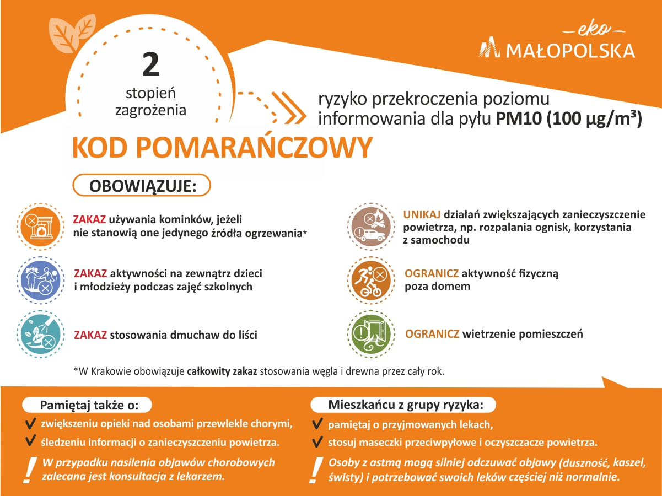

Więcej informacji:

- Aktualna jakość powietrza w Małopolsce
- Wpływ zanieczyszczenia powietrza na zdrowie
- Wymagania uchwał antysmogowych obowiązujących w Małopolsce
- Dostępne programy dofinansowania do wymiany ogrzewania, ocieplenia budynku i instalacji odnawialnych źródeł energii

